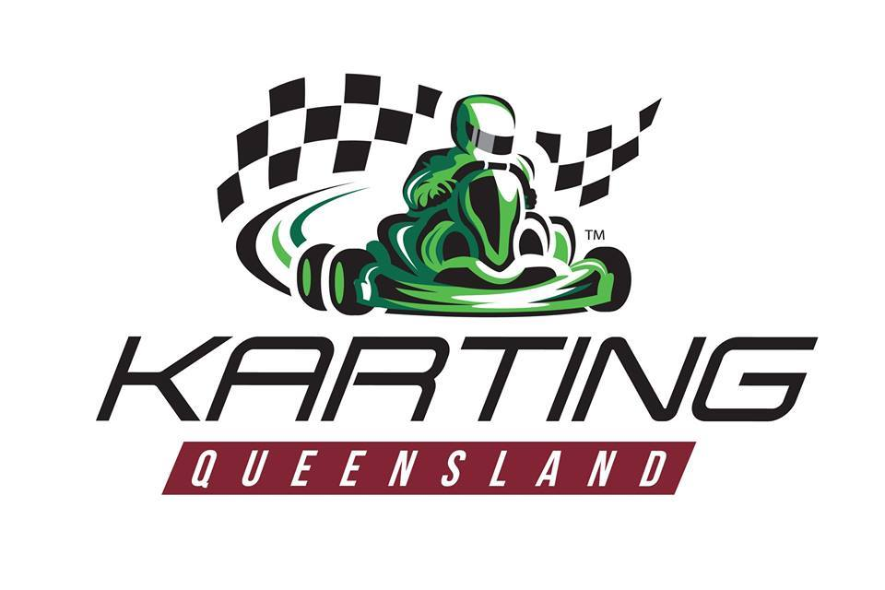

AUSTRALIAN KARTING ASSOCIATION QLD INC.
STRATEGIC PLAN 2022 – 2025

PLANNING TO CREATE BETTER KARTING COMMUNITIES THAT
WORK AND PLAY TOGETHER

AUSTRALIAN KARTING ASSOCIATION QLD INC STRATEGIC PLAN 2022 – 2025
1.0 | VISION  To support within the State of Queensland the Karting Australia Vision for Australian Karting to be recognised as a destination sport and the starting point of local, state, national and international motor racing with a community of karting clubs that provide motorsport activities that are enduring, inclusive, well organised, safe, exciting, fun and family friendly for people of all ages.
2.0 | PURPOSE  Through our Queensland Karting Community – our Affiliated Clubs, and Competitions at all levels, we will inspire and encourage more people to participate in the sport of karting as a competitive sport and as a recreational activity thereby enlivening and growing karting within Australian Karting Association QLD Inc.
3.0 | MISSION  Our Mission is to lead, govern, promote and grow the sport of karting in Queensland and to be an effective and collegiate MEMBER of Karting Australia.  - The Queensland karting community will constantly strive to provide a respectful, safe, fun, family oriented, well organised, time efficient, value for money motor sport for participants of all ages  - The Karting Australia Board and Management will strive to provide leadership, governance and guidance to the national karting community  - The Queensland Management and Executive Committee’s will strive to provide effective leadership, governance and guidance with ‘whole of sport’ objectives that are aligned with Karting Australia’s objectives to our entire karting community  - Our Clubs Management and Executive Committees will strive to provide effective leadership and management with ‘whole of sport’ aligned objectives to their Club community  - We commit to always provide karting competition for our members that is conducted with fairness and integrity  - We commit to provide a sporting framework that ensures that our Clubs are welcoming, respective and inclusive  - We commit to provide social and recreational karting for our members that is fun and well organised  - We will strive to achieve increased diversity of participation in motorsport  - We will develop the value of our brand and in so doing will establish and grow partnerships with key stakeholders and sponsors to improve the business and the sport of karting in Queensland
4.0 | KARTING QLD CORE VALUES -R.E.S.P.E.C. T  - Respect - Participation - Teamwork  - Excellence - Enjoyment  - Sportsmanship - Courtesy
5.0 | OUR GOALS AND KEY STRATEGIES
5.1 | GOAL: EXPAND KARTING’S PROFILE  KEY STRATEGIES:  - Support, encourage and implement Karting Australia programs that are designed to expand karting’s profile in Queensland  - Develop and implement a diverse Queensland ambassador program  - Effective use of club and state database information to manage and maximise communication opportunities  - Elevate the state’s membership base to improve the profile of the sport  - Harness and utilise the power of social media for the promotion of karting, to grow awareness of the sport at a grassroots level  - Ensure that Clubs are mindful and informed to enable them to drive local area awareness of the sport and the Club
5.2 | GOAL: GROW DRIVER MEMBERSHIP AND PARTICIPATION  KEY STRATEGIES:  - Support, encourage and implement Karting Australia programs that are designed to grow driver membership and participation in Queensland  - Harness the power of social and local media for the promotion of karting, karting clubs, karting competition and recreational club karting to grow the sport and its participants, followers and supporters  - Support the Clubs in respect to the needs and the benefits of promoting and acting locally to drive membership of the Club  - Grow initiatives to increase participation across competitive and social karting activities whilst building upon and promoting lower cost club karting initiatives  - To further develop and promote club competition encouragement measures including initiatives such as Club Driver Rankings and Ultimate Club Racer  - Utilise and encourage implementation of Karting Australia initiatives to increase diverse participation in karting (eg Girls Race Too)  - Encourage the development of new events that are unique, family friendly and offer maximum participation  - Encourage the development of new programs that address the needs of the social Karter that are easily organised, time effective, safe and social  - Encourage Clubs to be active in their local communities and support new members  - Capture and analyse statistical data on all karting participation – both social and competition

5.3 | GOAL: ENRICHING OUR PEOPLE AND CULTURE  KEY STRATEGIES:  - Support, encourage and implement Karting Australia initiatives that are designed to enrich our people and culture in Queensland  - Strive for continual club improvement as a core element of the Building Better Kart Clubs program  - Implement the ‘Respect Karting’ program to improve the karting experience for all participants  - Always apply the highest standards of governance at State and Club levels  - Ensuring that karting is conducted with fairness and integrity and in accordance with the Rules at all times  - Cultivate and adopt a culture of collaboration between all stakeholders and encourage sharing of ideas, innovations and success between clubs
5.4 | Goal: ADDRESS THE KEY ISSUE OF VOLUNTEER MANAGEMENT  KEY STRATEGIES:  - Support, encourage and implement Karting Australia initiatives designed to address the key issue of volunteer management in Queensland  - Assist in the development and implementation of appropriate framework, plans and resources for volunteer attraction, training, management and retention strategies  - Develop and deliver quality training programs for officials, volunteers and club administrators  - Implement structures which ensure quality, accountability and consistency across national, state and club levels.  - Develop and implement Club and State Volunteer recognition programs  - Develop and cross promote volunteer opportunities with like-minded organisations in Queensland
5.5 | GOAL: DEVELOP HIGH PERFORMANCE  KEY STRATEGIES:  - To develop and offer State and regional karting competitions that allow participants to compete in larger, well organised, well promoted and structured race meetings  - Encourage drivers within Queensland who desire to compete at higher levels within Queensland, nationally and internationally to do so within the national competition structure
5.6 | GOAL: ENSURE KARTING’S SUSTAINABILITY  KEY STRATEGIES:  - Support, encourage and implement Karting Australia initiatives that are designed to ensure karting’s sustainability in Queensland  - Develop sound commercial relationships that enhance karting’s brand profile  - Expand the state’s revenue streams through new sponsors, partners and grants programs  - Encourage Clubs to expand their revenue streams through new sponsors, partners and grants programs  - Seek and try to obtain grants for initiatives to grow the sport and introduce new participants to karting

6.0 | TRACK MAP - FROM ‘LIGHTS OUT’ TO CHEQUERED FLAG 2022 - 2025
The specific programs and initiatives outlined below form part of the Karting Australia Strategic Plan which Australian Karting Association QLD Inc will align to over the term of this strategic plan. These are things that we intend to do that will help us to achieve our goals against those defined by our national governing organisation. A key element of planning to succeed is to ensure that we closely align our goals and the things that we do to achieve the goals of our national body. Similarly, it is also essential for our member clubs to align their objectives and goals with this developed document.

GOAL | DECEMBER 2022 | DECEMBER 2023 | DECEMBER 2024 | DECEMBER 2025
EXPAND KARTING’S PROFILE | Karting Australia’s Proposed Initiatives to Help It to Achieve Its Strategic Goals
 | Expand KA’s Partnership Programs  - Aust. F1 GP and Supercars | Conduct awareness programs with Clubs at F1 and Supercars events | Conduct awareness programs with Clubs at F1 and Supercars events | Conduct awareness programs with Clubs at F1 and Supercar events
 | Develop a Karting Ambassador Program - Appoint at least 1 Ambassador in each State | Have 20 Ambassadors in place  - Ensure that at least 20% of Ambassadors are female | Have 30 Ambassadors in place | Have 40 Ambassadors in place
 | Conduct a National Membership Drive  November:  ‘National Karting Awareness Month’ including:  “WELCOME TO KARTING DAY” | “CLUB KARTING STARTS NOW”  Conduct ‘National Club Start-up Month’ to launch the official 2020 Club Karting Season  November 2023:  ‘National Karting Awareness Month’ including:  “WELCOME TO KARTING DAY II” | “CLUB KARTING STARTS NOW”  Conduct ‘National Club Start-up Month’ to launch the official 2021 Club Karting Season  November 2024:  ‘National Karting Awareness Month’ including:  “WELCOME TO KARTING DAY III” | “CLUB KARTING STARTS NOW”  Conduct ‘National Club Start-up Month’ to launch the official 2022 Club Karting Season  November 2025:  ‘National Karting Awareness Month’ including:  “WELCOME TO KARTING DAY IV”
 | Develop new KA web site | Launch New KA web site
Run a minimum of 2 National Social Media promotions annually from 2022 to 2025 e.g.
- Hashtag promotion on Facebook, YouTube and Instagram
- Run a “Thanks Mum” Mother’s Day and “Thanks Dad” Father’s Day promotion
 | Australian Karting Association Qld Inc Proposed Initiatives to Help It to Achieve Its Strategic Goals
 |  | Initiate and engage with KA on appointing two ambassadors  - Suggestion of Brock Feeney, Declan Fraser & Maddison Dunston, Madeline Stewart  - Michelle to discuss with Kelvin | Continue working with KA on appointment of first ambassador | Continue working with KA on appointment of second ambassador
Develop a social media program
- Facebook & Instagram working well
- Website being updated by KA
- Janet to do up a plan of each Club sharing a Driver or Official profile
- Respect profile to be done up as the first promotional
 |  | Utilise email to communicate directly with Karter’s and Officials  - Qtr. Newsletter produced by Janet | Continue to monitor and analyse the effect use of emails | Continue to monitor and analyse the effect use of emails
GROW DRIVER MEMBERSHIP AND PARTICIPATION | Karting Australia’s Proposed Initiatives to Help It to Achieve Its Strategic Goals
 | Re-launch “Bring A Mate Day” program - Fresh look, greater visibility, and hype for the program | Share success stories across the entire Australian karting community
 | Every Club runs at least one stand alone “Bring A Mate” day
Actively promote Club Driver Rankings and the Ultimate Club racer event at every opportunity to drive participation at Club level
Leverage Ultimate Club Racer throughout the entire year
 |  | Launch Karting Australia App V1
 |  | Develop and launch Junior and Senior female club karting encouragement program
 |  | Create, develop and launch national “KART FUN MONTH”
 | Australian Karting Association Qld Inc Proposed Initiatives to Help It to Achieve Its Strategic Goals
 |  | Look at effective ways to analyse the effectiveness of Social Karting days
 |  | Explore, implement and develop a focus group
New membership packs
Pre membership packs
ENRICHING OUR PEOPLE AND CULTURE | Karting Australia’s Proposed Initiatives to Help It to Achieve Its Strategic Goals
 | Ratify a new, AKA Constitution
 | Modify the KA Strategic Plan for adoption by each Member State
 | Develop and launch the “RESPECT KARTING” program | Build the “RESPECT KARTING” program | Further build the “RESPECT KARTING” program | Further build the “RESPECT KARTING” program
 | Conduct a Pilot “Club Development” Program | Expand the “Club Development” Program
 | Conduct a Pilot “State Association & Club Development” Program | Expand the “State Association & Club Development” Program
 | Conduct “BUILDING BETTER KART CLUBS 2” Conference | Conduct “BUILDING BETTER KART CLUBS 3” Conference | Conduct “BUILDING BETTER KART CLUBS 4” Conference | Conduct “BUILDING BETTER KART CLUB 5” Conference
 | Australian Karting Association Qld Inc Proposed Initiatives to Help It to Achieve Its Strategic Goals
 |  | Implement social media and promotional items to share our core values R.E.S.P.E.C. T | Implement and develop a Junior SKC
 |  |  | Start Constitution review | Continue Constitution review
 |  | Review Qld Policies | Review Qld Policies | Review Qld Policies
ADDRESS THE ISSUE OF VOLUNTEER MANAGEMENT  DEVELOP HIGH PERFORMANCE | Karting Australia’s Proposed Initiatives to Help It to Achieve Its Strategic Goals
 | Develop a Volunteer Management Framework (VMF) and Program | Implement a Volunteer Management Program in line with the VMF | Implement Club, State and National Volunteer management and recognition programs
 | Develop and implement on-line training module for “Introduction to Karting” | Develop and implement on-line training modules for:  “General Officials” and  “Event Command” and “Stewarding”
 | Continue to promote the Australian Kart Championship as the pinnacle competition of Australian Karting
 | Work with the State Associations to create well-structured Zonal/State Series competitions
 | Ensure that Australia’s top-level karting competitions create relevant pathways to higher level racing for those who wish to purse their racing aspirations
 | Australian Karting Association Qld Inc Proposed Initiatives to Help It to Achieve Its Strategic Goals
 |  | Register with Volunteer Qld | Maintain membership with Volunteer Qld | Maintain membership with Volunteer Qld
 |  | Develop new volunteer packs
 |  | Social Media ads to entice volunteers | Align and promote volunteer programs & recognition
 |  | Develop & Commence Officials training
 |  | Track inspection training
ENSURE KARTING’S SUSTAINABILITY | Karting Australia’s Proposed Initiatives to Help It to Achieve Its Strategic Goals
 | Develop a portfolio of sponsorship opportunities | Establish Sponsorship targets
 | Identify potential sponsorship targets and take the sponsorship offerings to market | Expand Karting’s National sponsorship portfolio
 | Develop programs that will increase appeal to women to start to race | Develop and launch Junior and Senior female club karting encouragement program
 | Research and develop a grants access program | Implement a Grants Access Program
 | Australian Karting Association Qld Inc Proposed Initiatives to Help It to Achieve Its Strategic Goals
 |  | Review State Regulations | Review State Regulations | Review State Regulations
 |  | Identify Grants & apply using professional Grant writer
 |  |  | Working towards future requirements of each club
 |  | Assist clubs in meeting affiliation requirements including KARM, MPIO etc
 |  | Review Track Development Fund  Consider a Club Assistance program | Review Track Development Fund | Review Track Development Fund

